Chad Galloway

CST-250 Programming in C# II

Grand Canyon University

Oct. 26, 2025

Activity 1

Files

<https://github.com/CGalloway3/CST-250-Projects/tree/master/Activity%201>

Video

[Video Link]

**Part 1**

FLOW CHART

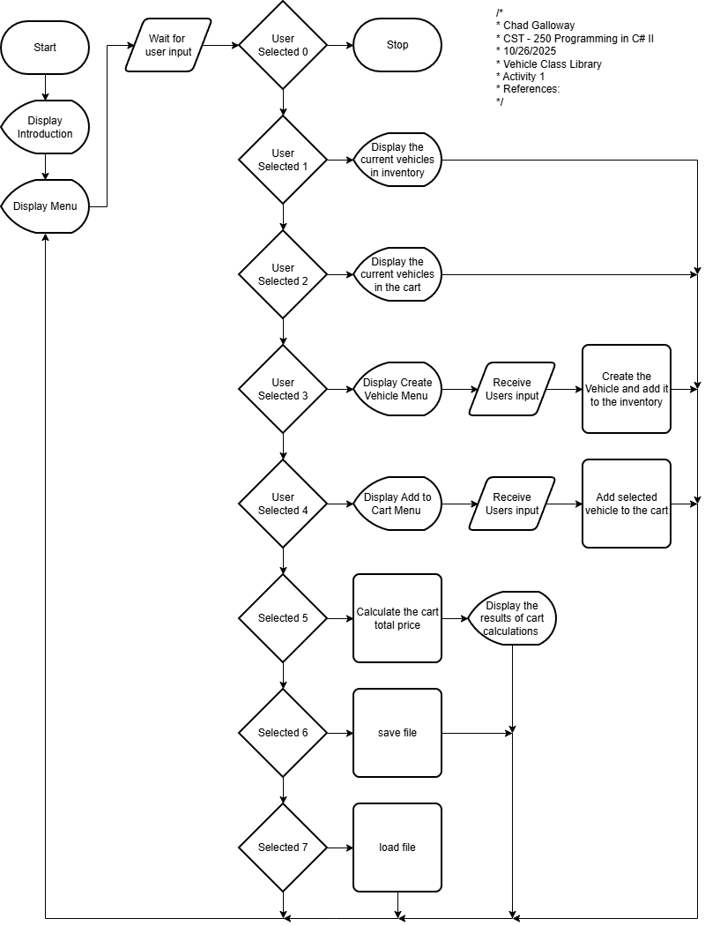

Figure X: Flow chart of XXXXXXX

"Lorem ipsum dolor sit amet, consectetur adipiscing elit, sed do eiusmod tempor incididunt ut labore et dolore magna aliqua. Ut enim ad minim veniam, quis nostrud exercitation ullamco laboris nisi ut aliquip ex ea commodo consequat. D

UML Class Diagram

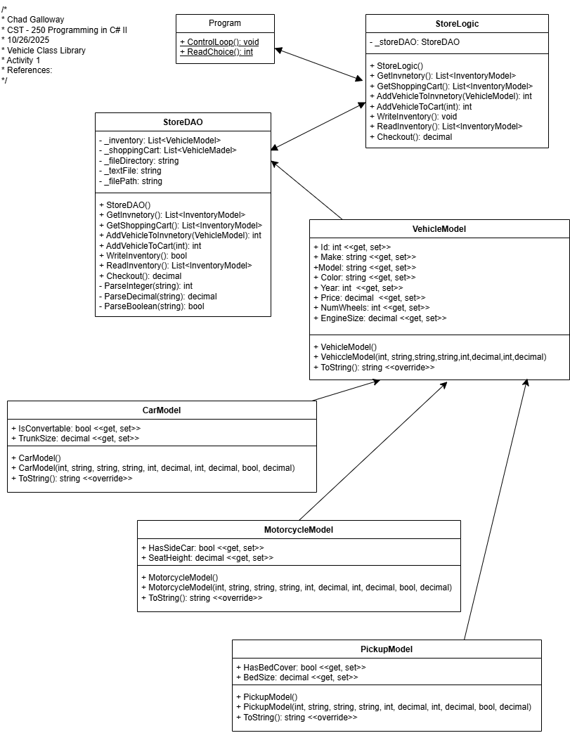

Figure X: UML Class Diagram

Lorem ipsum dolor sit amet, consectetur adipiscing elit, sed do eiusmod tempor incididunt ut labore et dolore magna aliqua. Ut enim ad minim veniam, quis nostrud exercitation ullamco laboris nisi ut aliquip ex ea commodo consequat. Duis aute irure dolor in reprehenderit in voluptate velit esse cillum dolore eu fugiat nulla pariatur. Excepteur sint occaecat cupidatat non proident, sunt in culpa qui officia deserunt mollit anim id est laborum.

Screen Shots

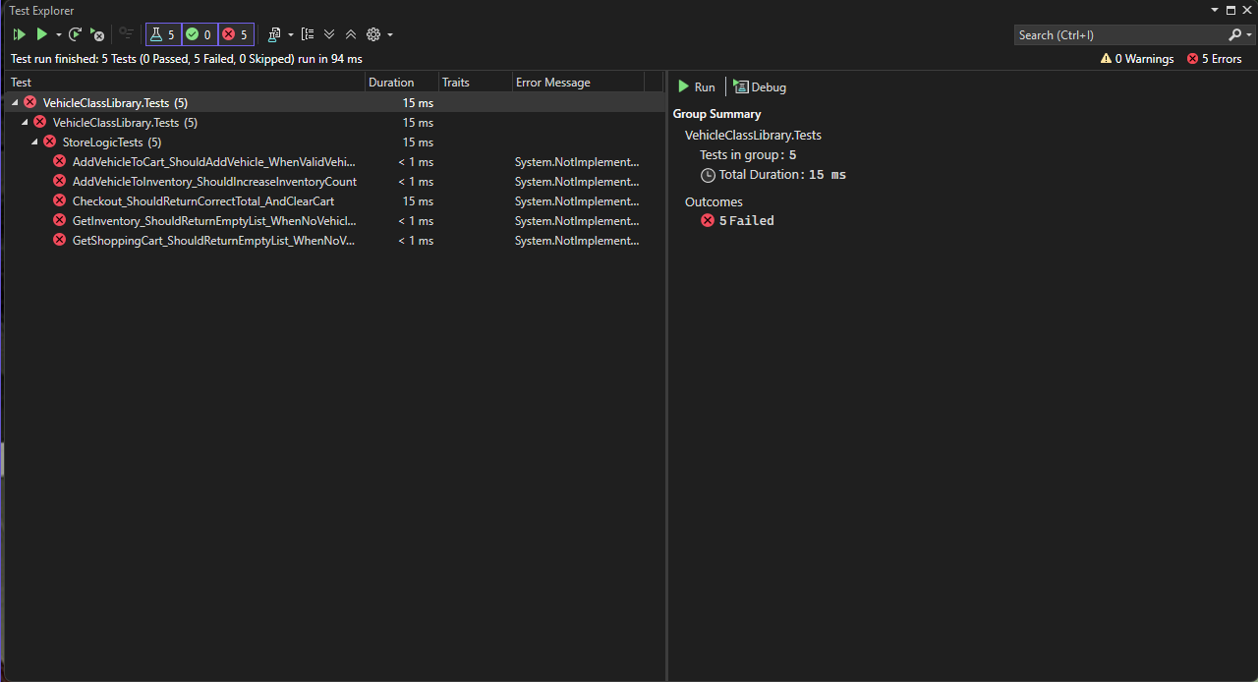

Figure 3: Screenshot of xUnit test

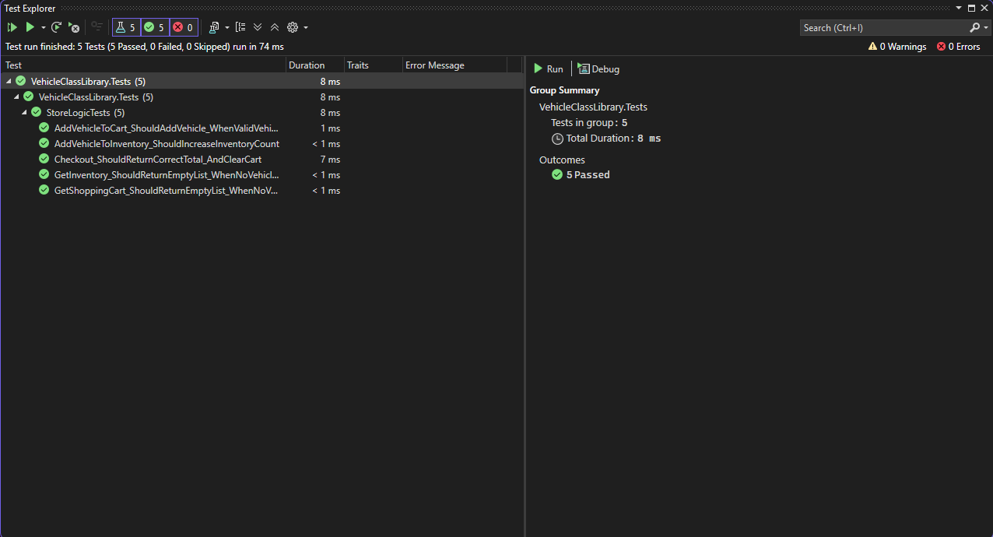

Figure 4: Screenshot of unit test

Figure 3 and 4 are screenshots of the unit tests. 3 is unsuccessful and 4 is successful completion of the tests.

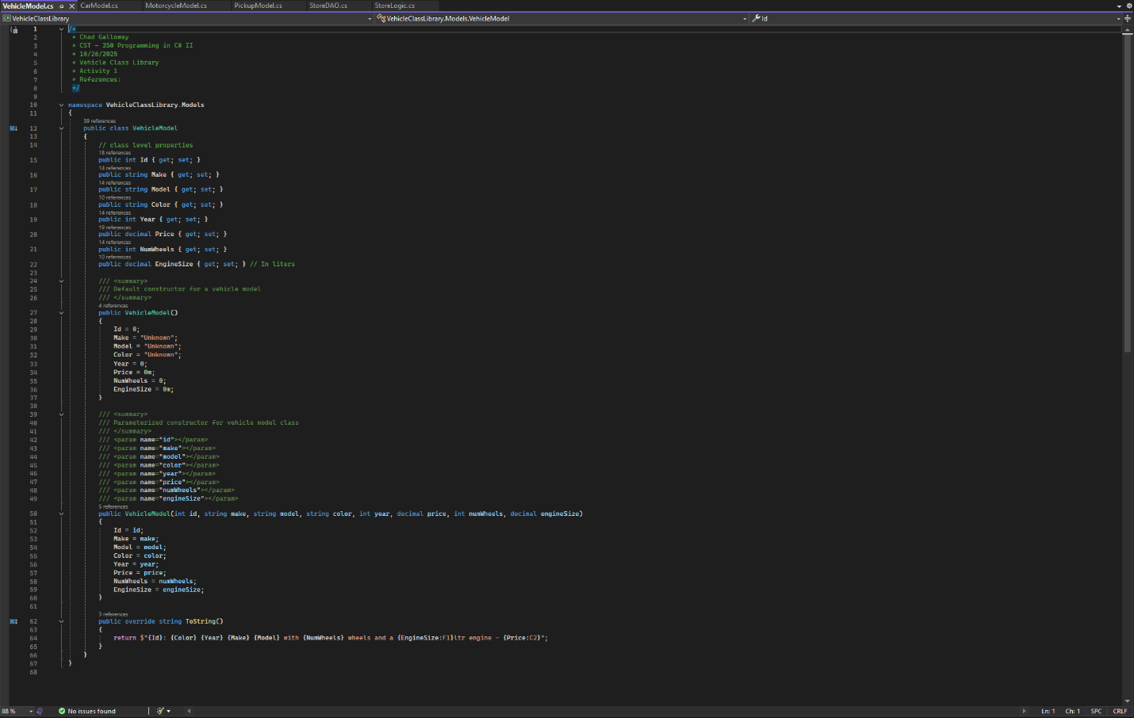

Figure 5: Vehicle Model

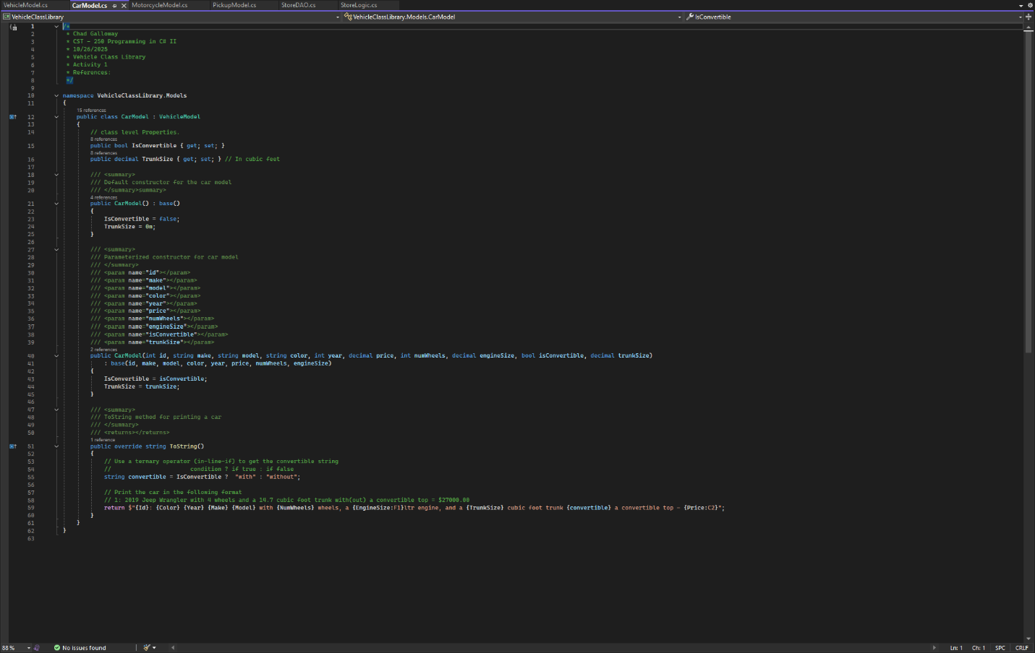

Figure 6: Car Model

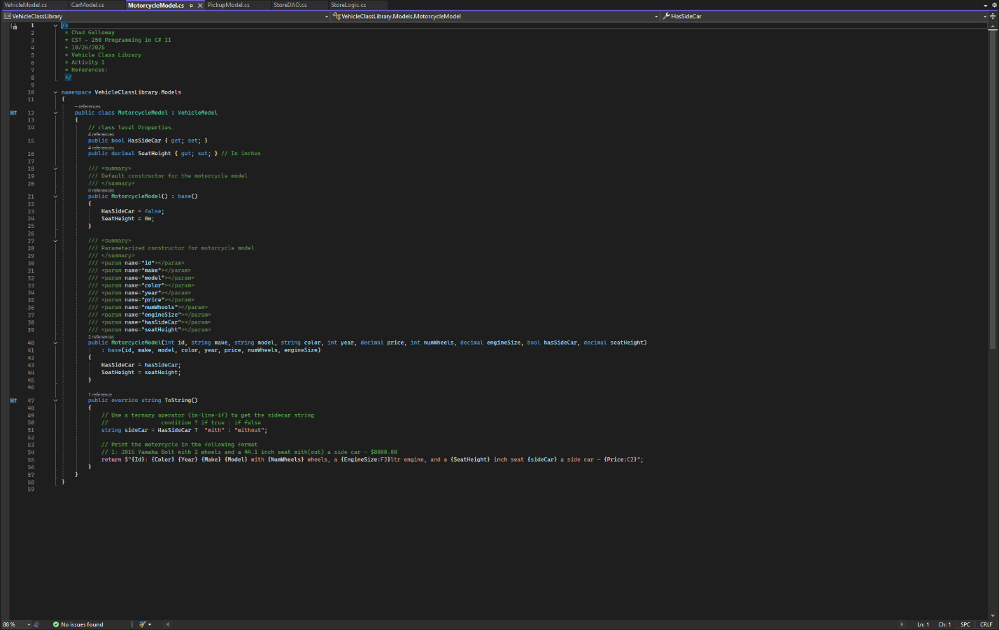

Figure 7: Motorcycle Model

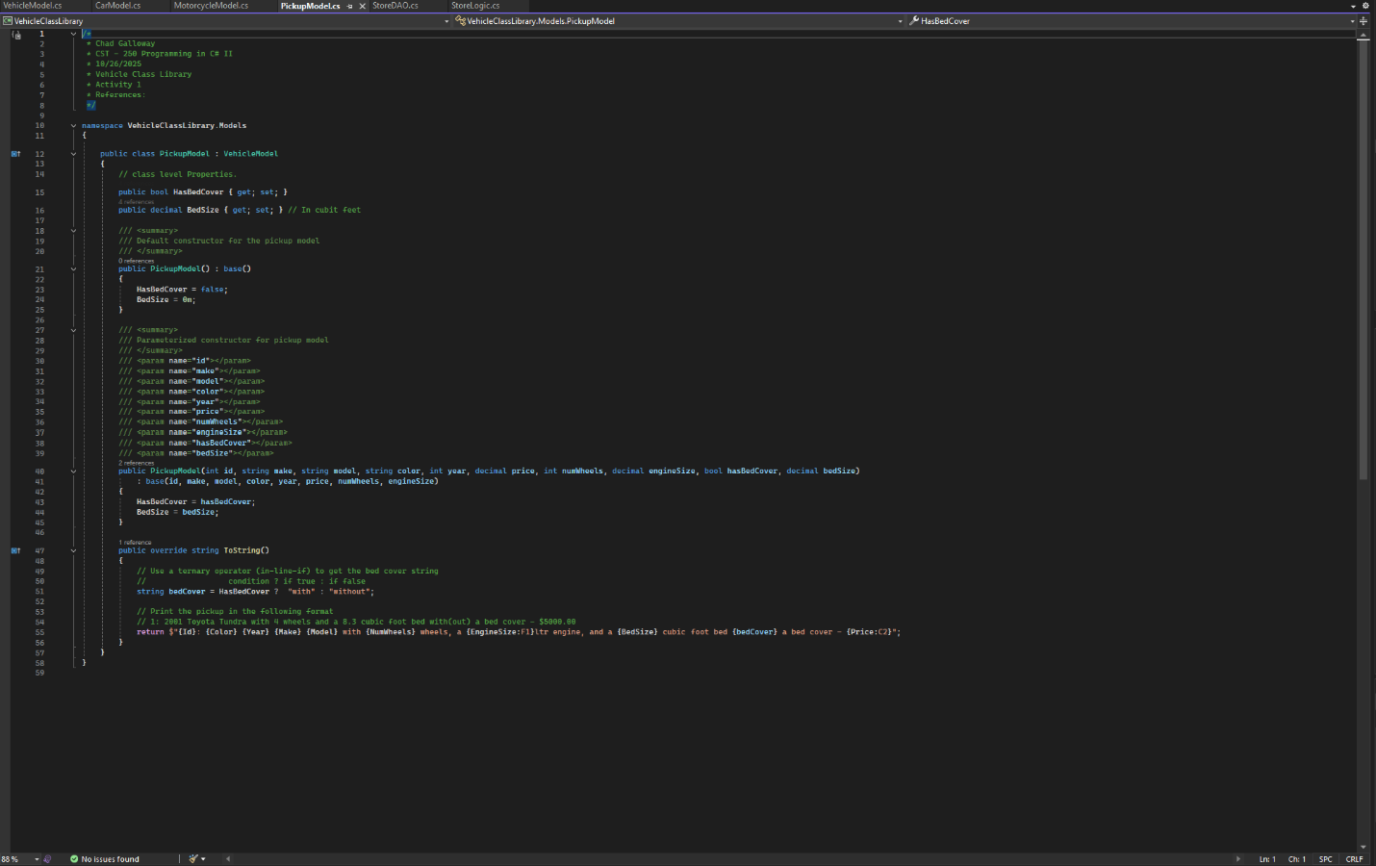

Figure 8: pickup model

Figures 5, 6, 7, and 8 are screen shots of the different models for vehicles in the application. Each screenshot covers the citations, constructors, and the overridden ToString() methods.

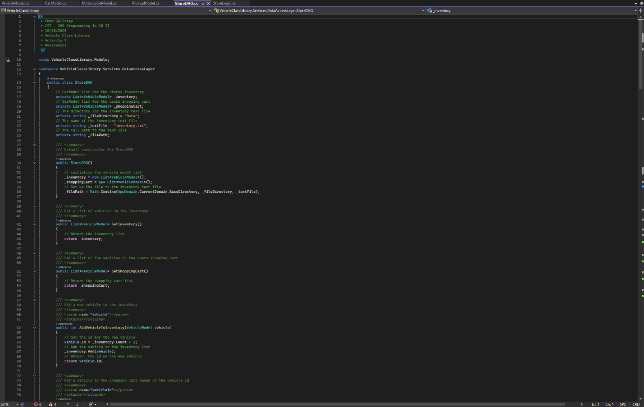

Figure 9: StoreDAO citations and constructors.

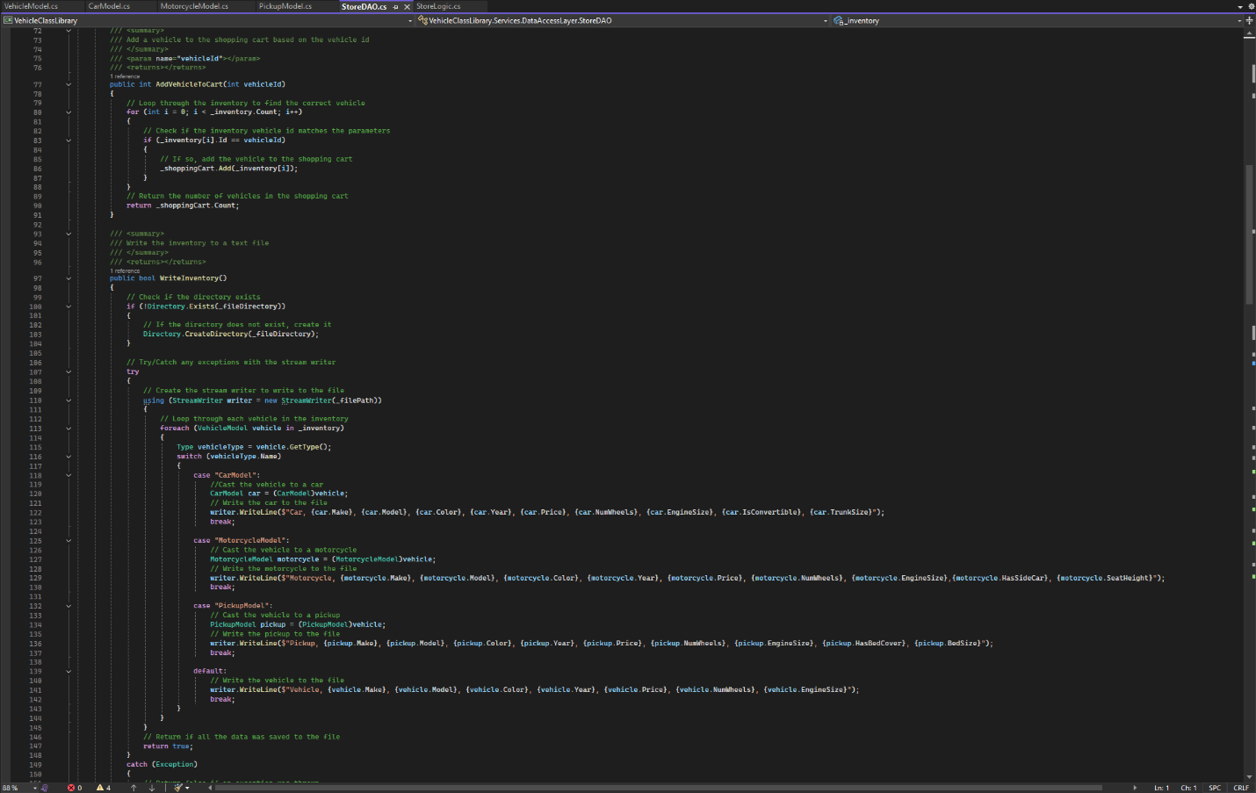

Figure 10: continuation of StoreDAO

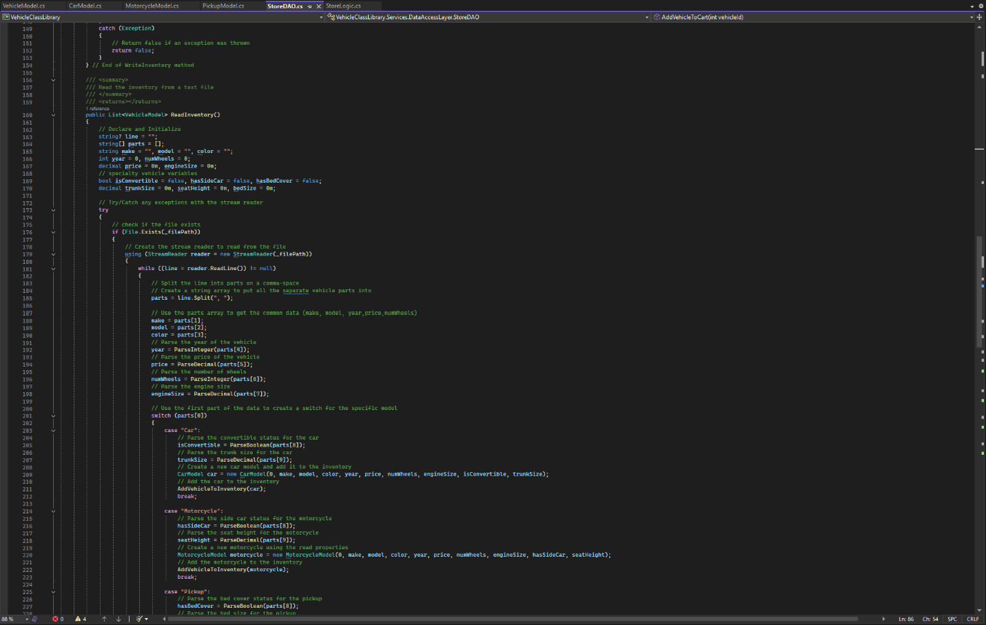

Figure 11: continuation of StoreDAO

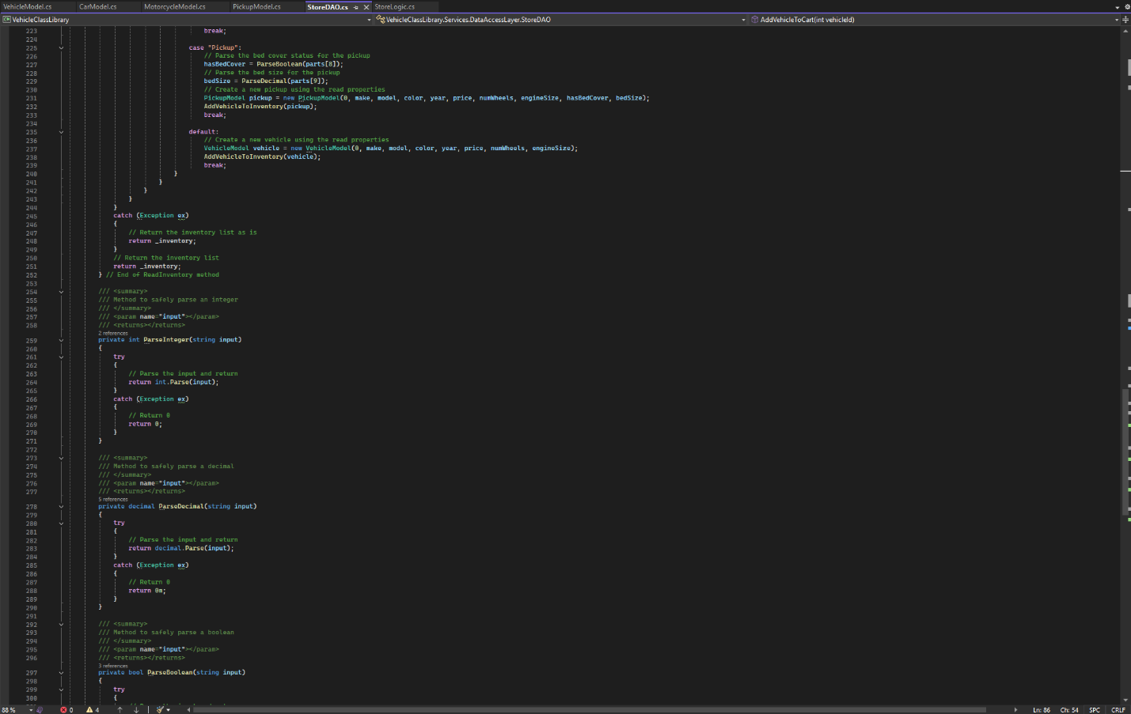

Figure 12: continuation of StoreDAO

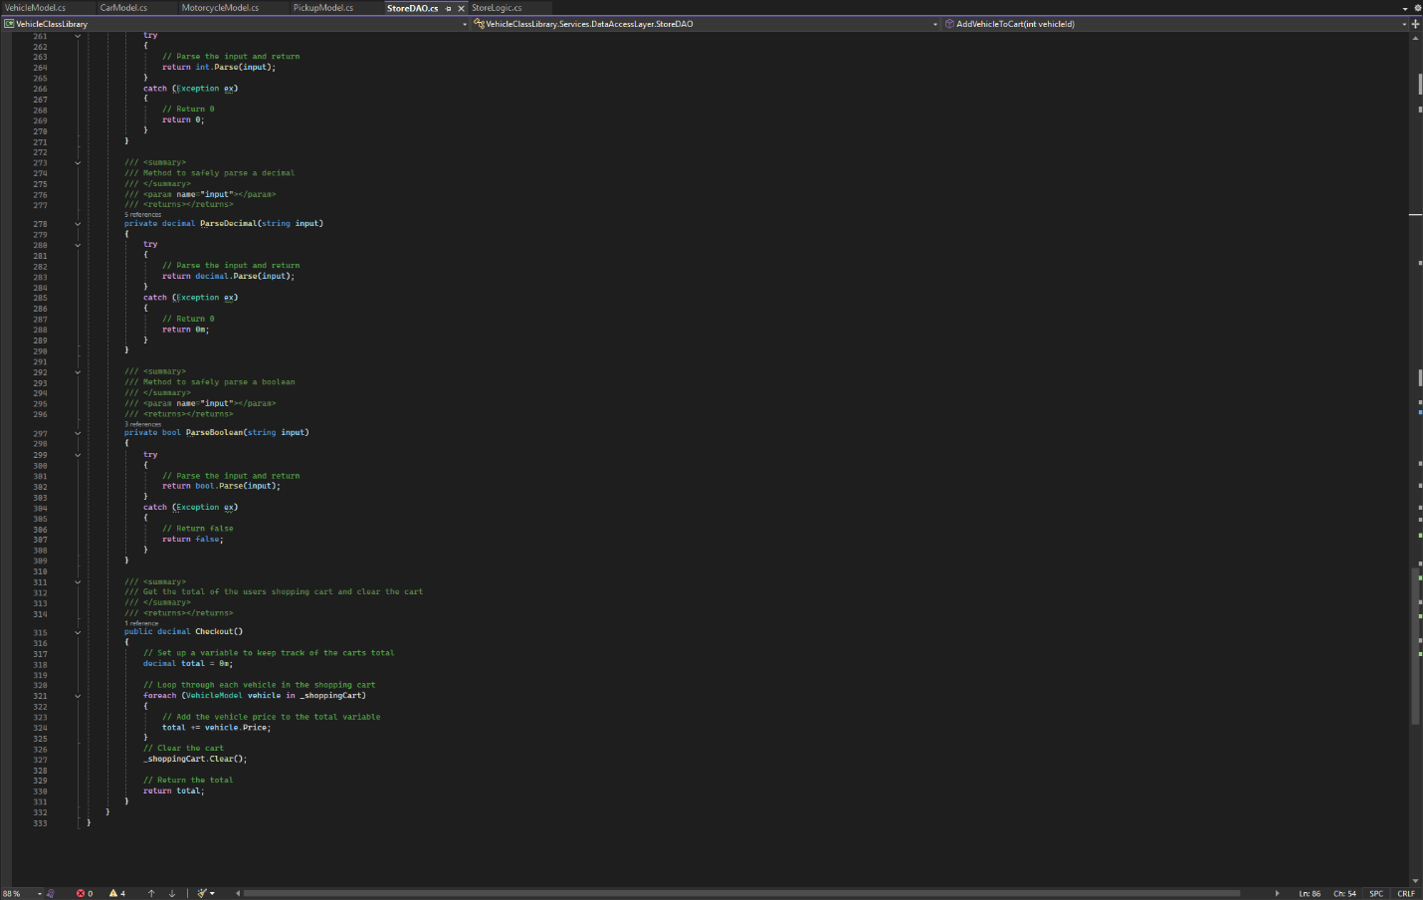

Figure 13: Final screenshot of StoreDAO

Figures 9-13 are screen shots of the StoreDAO class in its entirety. Every method is represented in the screen shots.

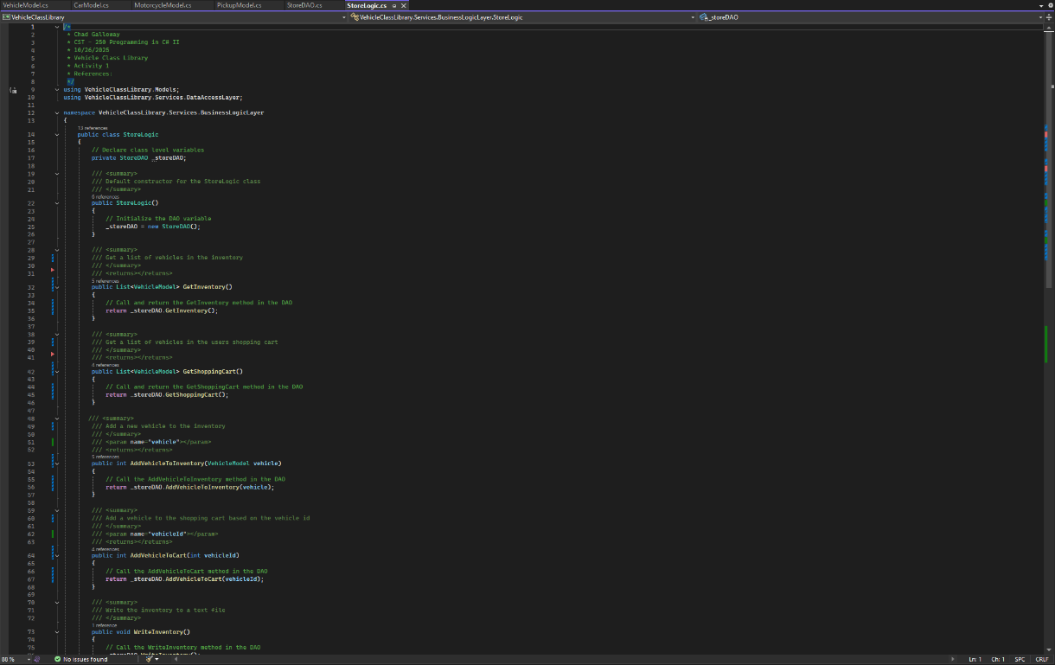

Figure 14: StoreLogic class citations and constructor

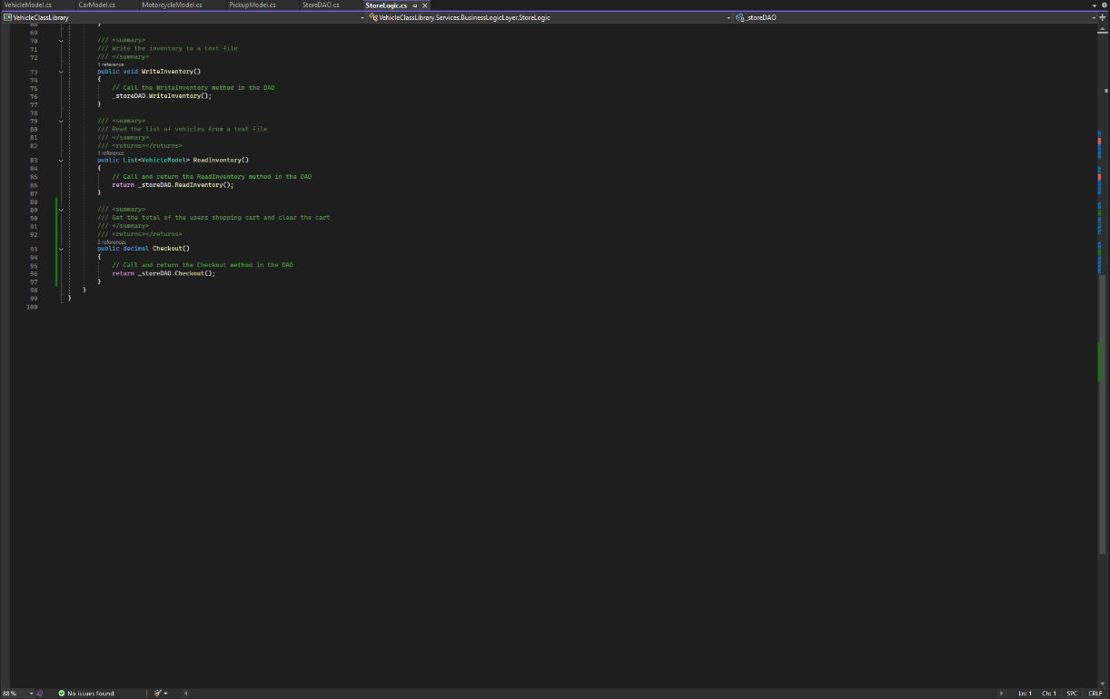

Figure 15: StoreLogic methods

Figure 14 and 15 are screenshots of the StoreLogic class.

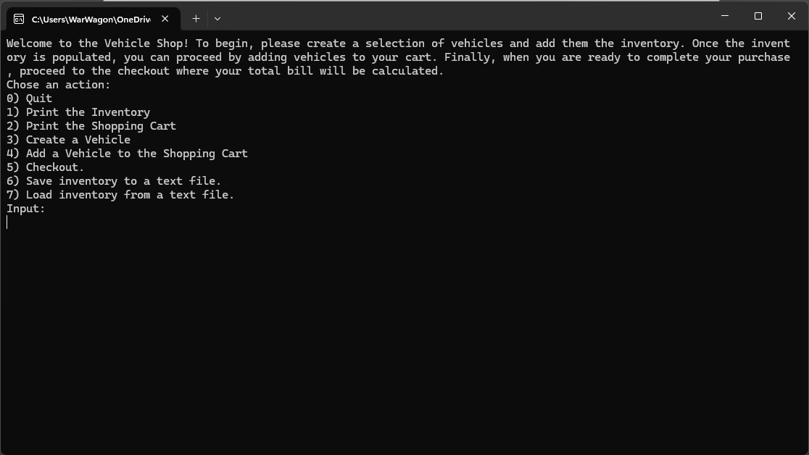

Figure 16: Initial load state of the console app

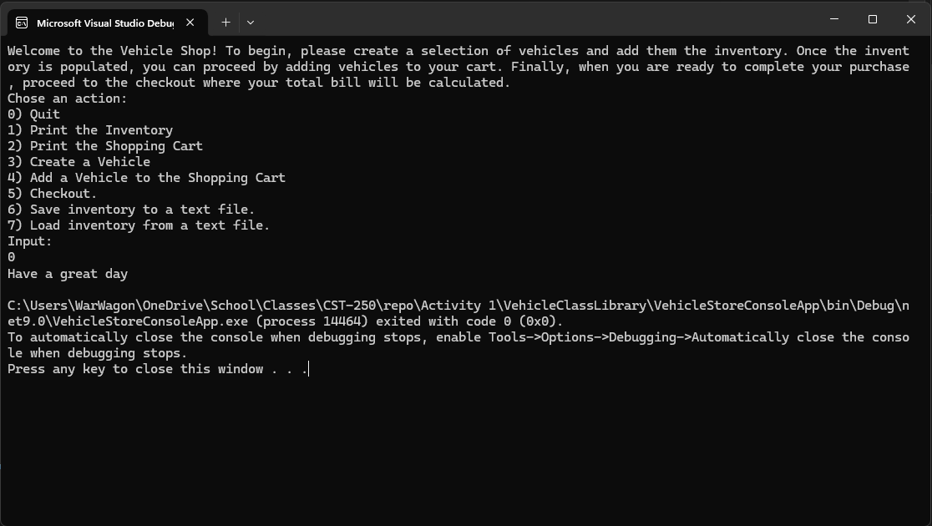Figure 17: user input 0

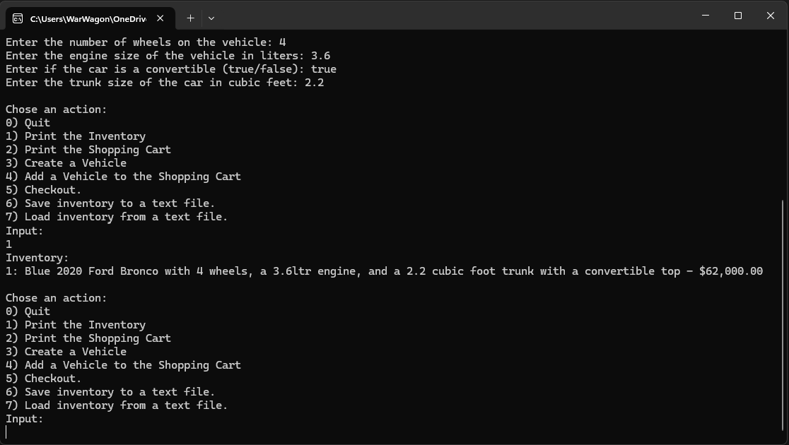

Figure 18: user input 1

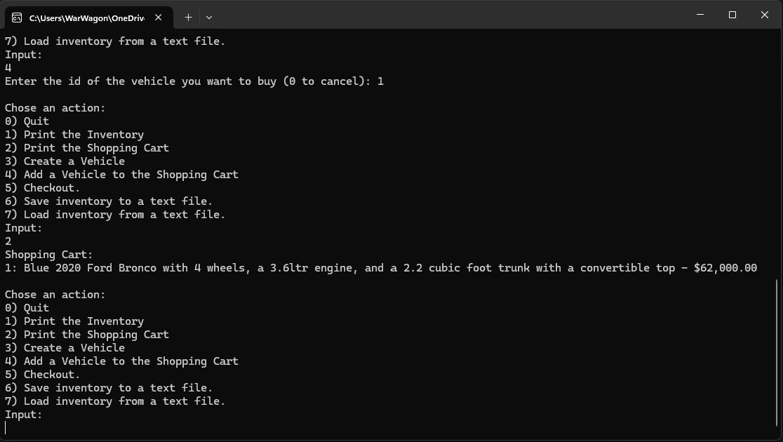

Figure 19: user input 2

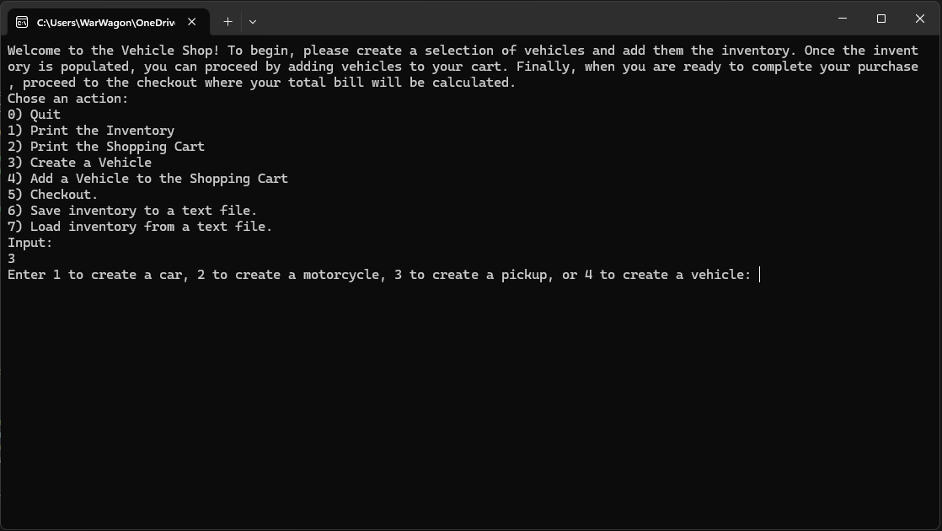

Figure 20: user input 3

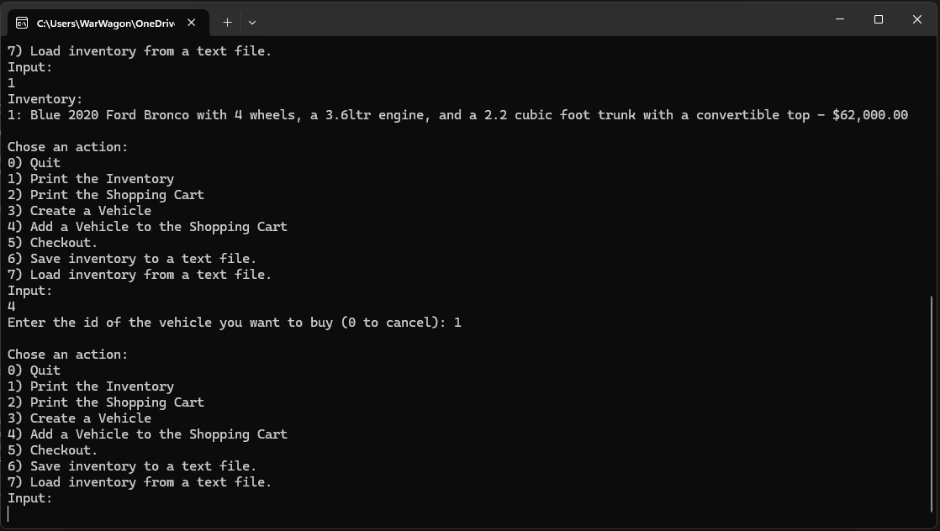

Figure 21: user input 4

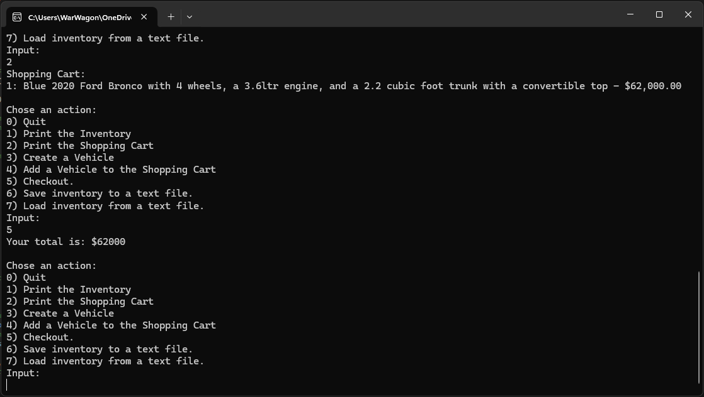

Figure 22: user input 5

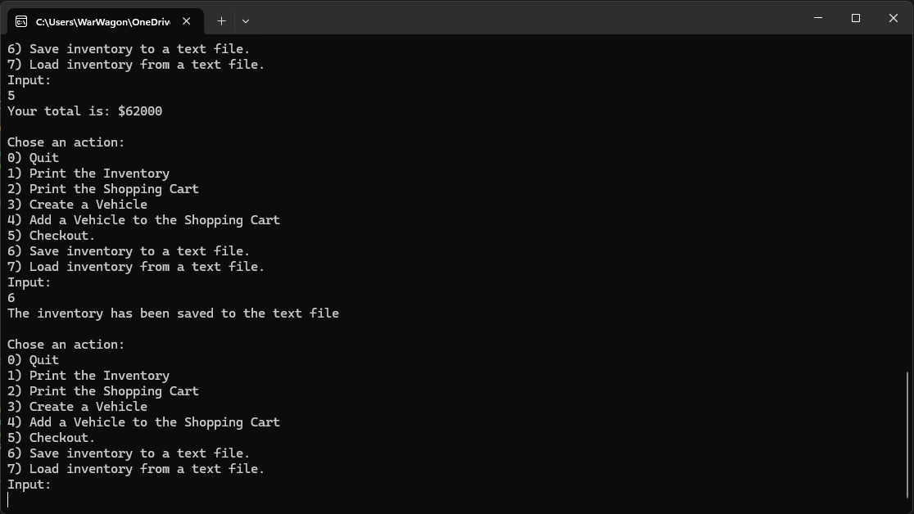

Figure 23: user input 6

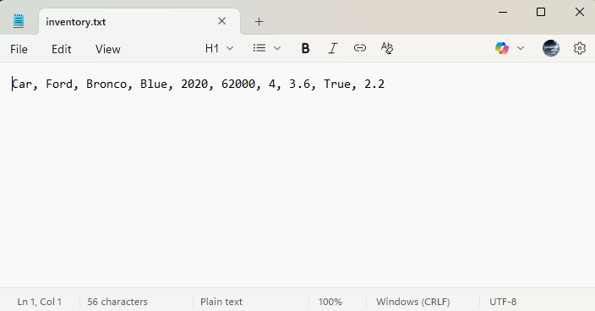

Figure 24: File contents after save (number 6)

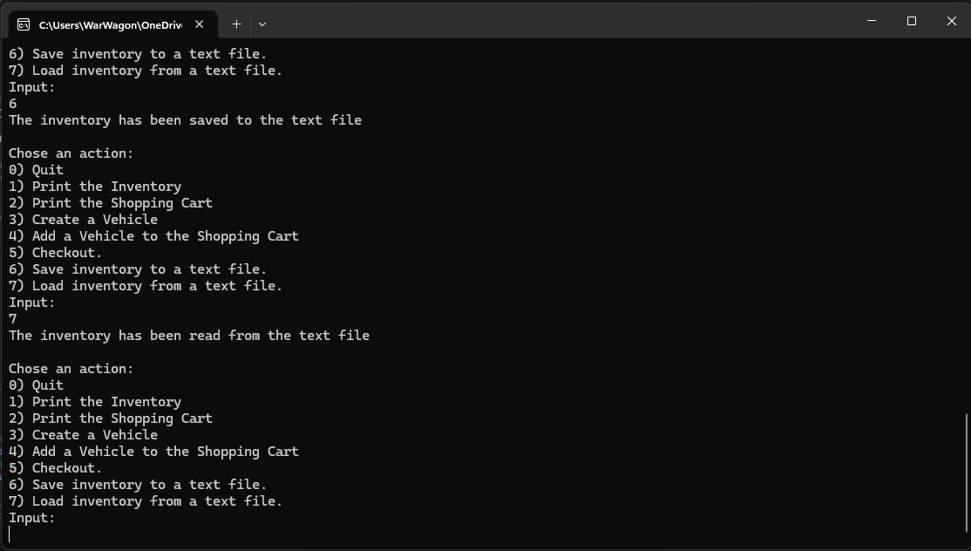Figure 25: user input 7

Figure 16- 25 are screenshots of the application running and demonstrating the different menu option selections made by the user

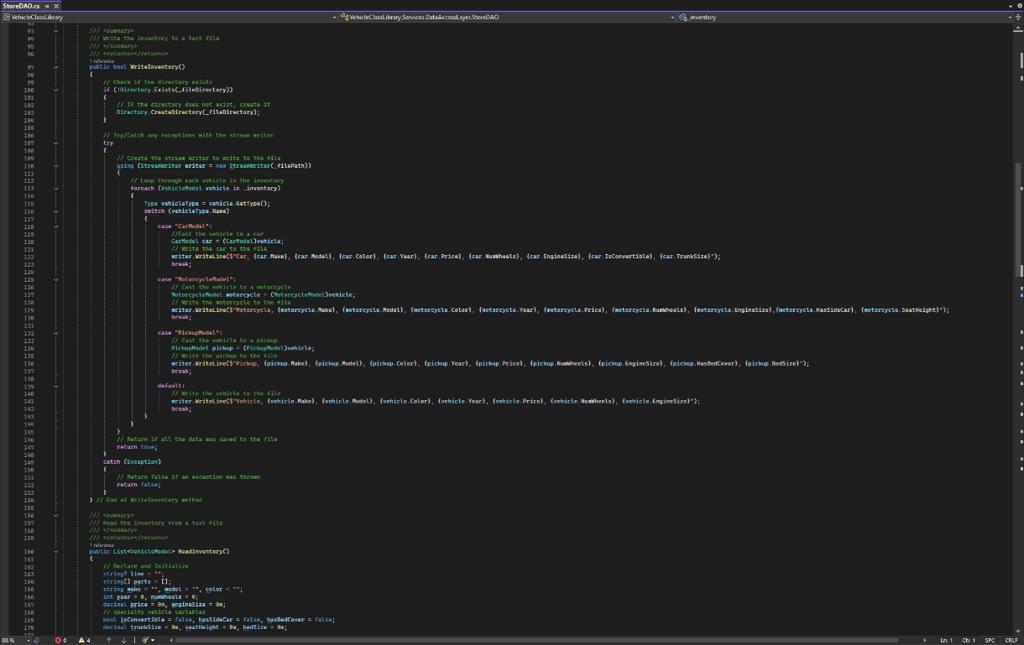

Figure 26: Challenge Changes

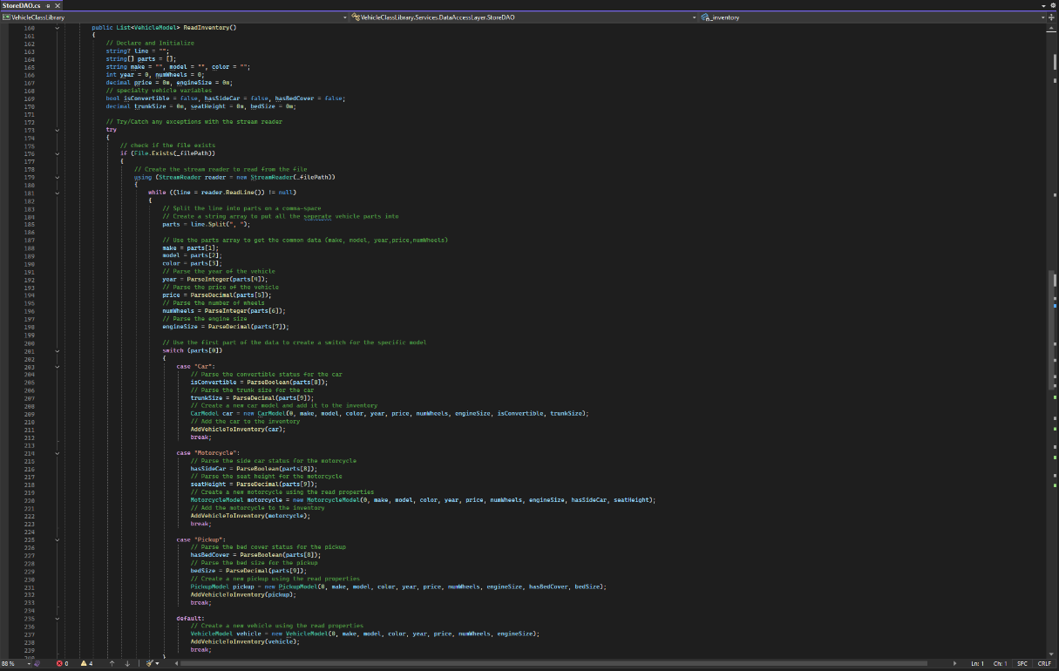

Figure 27 Challenge changes

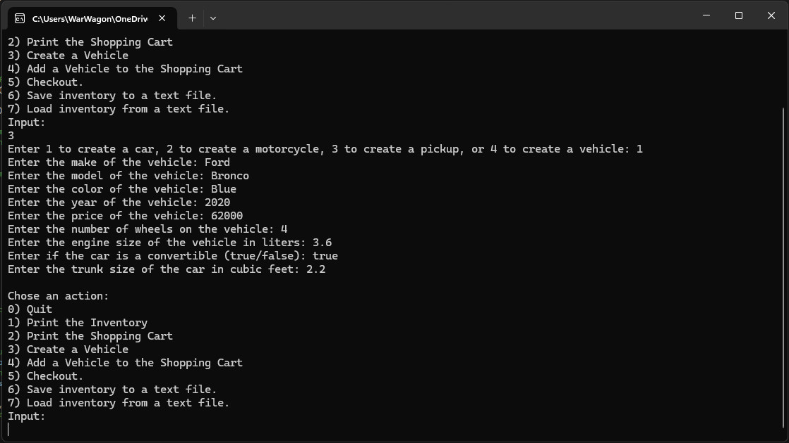

Figure 28: Changes running

Figures 26-28 are the changes to add the new properties and the application running with the new properties added to the create vehicle screens

**Part 2**

Screen Shots



Figure X: Screenshot of successful output

Lorem ipsum dolor sit amet, consectetur adipiscing elit, sed do eiusmod tempor incididunt ut labore et dolore magna aliqua. Ut enim ad minim veniam, quis nostrud exercitation ullamco laboris nisi ut aliquip ex ea commodo consequat. Duis aute irure dolor in reprehenderit in voluptate velit esse cillum dolore eu fugiat nulla pariatur. Excepteur sint occaecat cupidatat non proident, sunt in culpa qui officia deserunt mollit anim id est laborum.



Figure X: Screenshot of Error Handling

Lorem ipsum dolor sit amet, consectetur adipiscing elit, sed do eiusmod tempor incididunt ut labore et dolore magna aliqua. Ut enim ad minim veniam, quis nostrud exercitation ullamco laboris nisi ut aliquip ex ea commodo consequat. Duis aute irure dolor in reprehenderit in voluptate velit esse cillum dolore eu fugiat nulla pariatur. Excepteur sint occaecat cupidatat non proident, sunt in culpa qui officia deserunt mollit anim id est laborum.

**Part 3**

Screen Shots



Figure X: Screenshot of successful output

Lorem ipsum dolor sit amet, consectetur adipiscing elit, sed do eiusmod tempor incididunt ut labore et dolore magna aliqua. Ut enim ad minim veniam, quis nostrud exercitation ullamco laboris nisi ut aliquip ex ea commodo consequat. Duis aute irure dolor in reprehenderit in voluptate velit esse cillum dolore eu fugiat nulla pariatur. Excepteur sint occaecat cupidatat non proident, sunt in culpa qui officia deserunt mollit anim id est laborum.



Figure X: Screenshot of Error Handling

Lorem ipsum dolor sit amet, consectetur adipiscing elit, sed do eiusmod tempor incididunt ut labore et dolore magna aliqua. Ut enim ad minim veniam, quis nostrud exercitation ullamco laboris nisi ut aliquip ex ea commodo consequat. Duis aute irure dolor in reprehenderit in voluptate velit esse cillum dolore eu fugiat nulla pariatur. Excepteur sint occaecat cupidatat non proident, sunt in culpa qui officia deserunt mollit anim id est laborum.